**SMART DOOR ACCESS CONTROL SYSTEM WITH FACE RECOGNITION**

**-------------------------------------------------------------**

* **OBJECTIVE:**

**The primary goal of this project is to develop a robust and secure access control system using face recognition technology. The system ensures access only to authorized individuals, enhancing security and convenience. Key components include Arduino, a camera module, Firebase for data storage, Bluetooth for communication, and Node-RED for data visualization.**

**System Flowchart:  
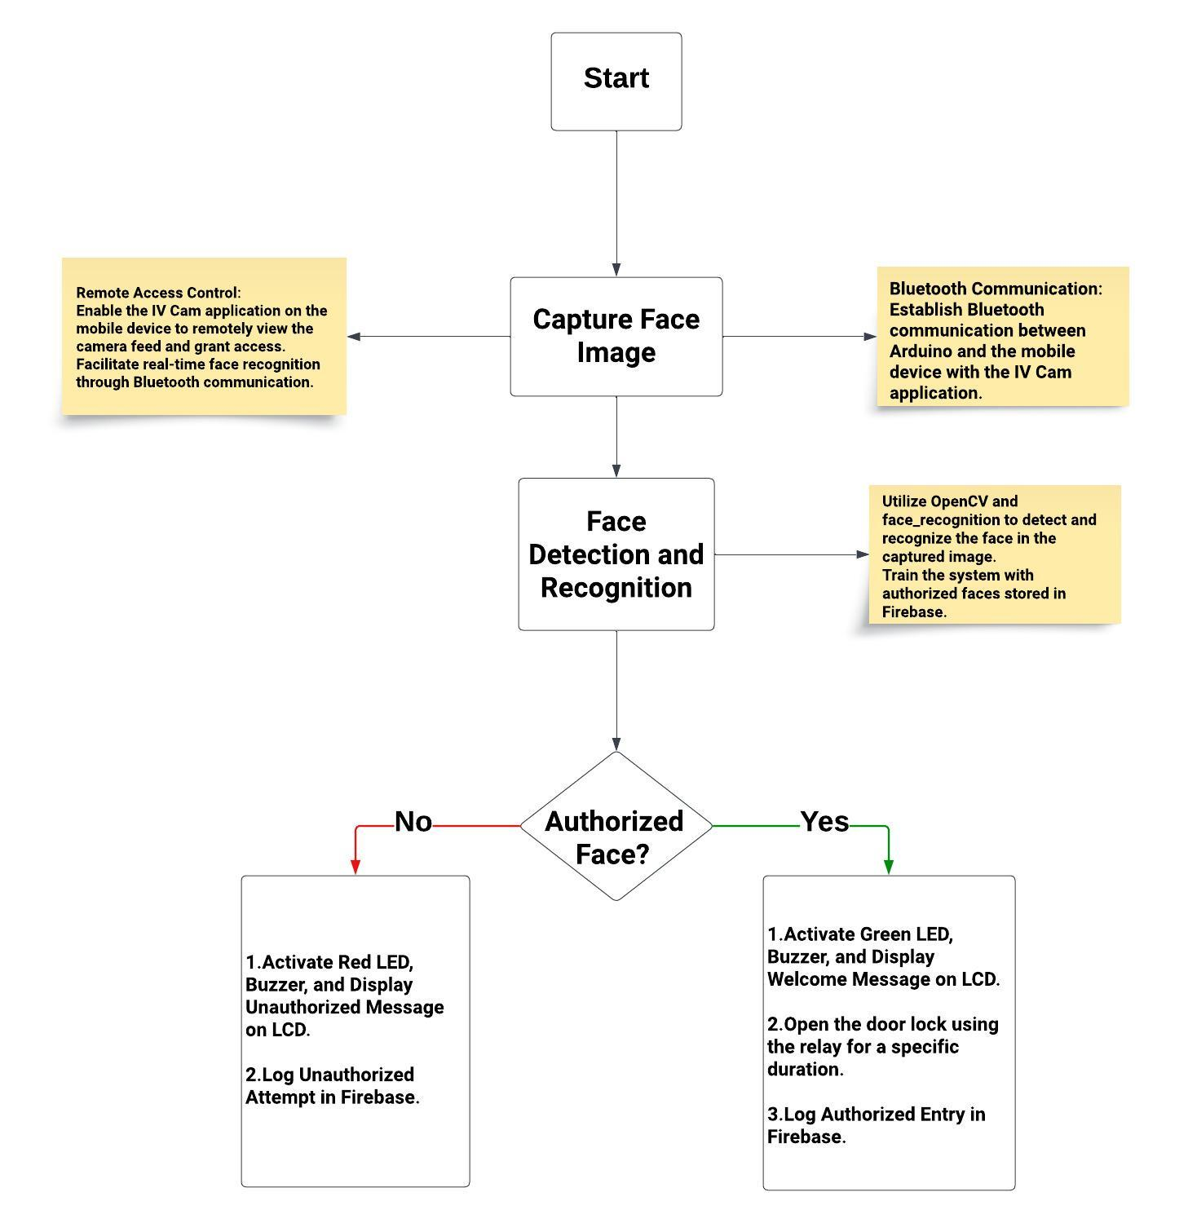**

* **SYSTEM ARCHITECTURE:**

1. **FACE DETECTION AND RECOGNITION:**
   * **Utilizes a camera module for image capture.**
   * **Implements face detection and recognition using a Python script on the Arduino board.**
   * **Trains the system with authorized faces and stores their unique identifiers.**
2. **ARDUINO INTEGRATION:**
   * **Connects the camera module and Arduino using appropriate pins.**
   * **Interfaces the electrical door lock and LED for access control.**
   * **Connects the buzzer for audible feedback.**
3. **BLUETOOTH COMMUNICATION:**
   * **Integrates the Bluetooth module to establish communication between Arduino and the mobile device running the IV Cam application.**
   * **Uses Bluetooth to transmit face data for recognition and receive access control commands.**
4. **FIREBASE INTEGRATION:**
   * **Utilizes Firebase for storing and managing authorized user data.**
   * **Implements a Python script to interact with Firebase, updating the database with recognized faces.**
5. **MOBILE APPLICATION:**
   * **Installs the IV Cam application on the mobile device.**
   * **Establishes a Bluetooth connection between the mobile device and Arduino for real-time face recognition.**
6. **Node-RED:**
   * **Each table in Firebase has a corresponding tab in Node-RED for data visualization.**
   * **Facilitates easy access to authorized personnel for monitoring and managing data.**

* **SYSTEM OPERATION:**

1. **ENROLLMENT:**
   * **Captures images of authorized individuals using the camera module.**
   * **Trains the system to recognize and stores unique identifiers for each authorized face in the Firebase database.**
2. **ACCESS CONTROL:**
   * **When an individual approaches the door, the camera captures their face.**
   * **The Arduino processes the image and compares it with the stored faces in the Firebase database.**
   * **If a match is found, the LED turns green, the buzzer sounds, and the door lock is released.**
3. **REMOTE ACCESS:**
   * **Uses the IV Cam application on the mobile device to remotely view the camera feed and grant access.**
   * **The mobile device communicates with the Arduino through Bluetooth, enabling secure and convenient access control.**

**PROJECT APPLICATIONS:**

**The project finds utility in educational settings, particularly for granting access to students and authorized individuals during specific times for classroom entry. Furthermore, it can be seamlessly integrated into eLearning platforms to automate class attendance, providing a versatile solution for educational institutions.**

**……………………………….**

**Overall Benefits:**

* **Improved security through biometric access control.**
* **Automation of attendance tracking and access management.**
* **Real-time monitoring and control via the IV Cam application.**
* **Customizable for various applications, making it a versatile solution.**
* **Reduction in administrative workload and human errors associated with manual systems.**
* **Integration with existing infrastructure for seamless implementation.**

*group MFSM*

*mohammad elewat 202010685*

*feras khrfan 202010598*

*mohammad barham 202020142*

*saif AL-hammed 202010356*